

RITESH KUMAR
Rich experience in executing full lifecycle development projects with a verifiable track record, targeting senior assignments in Software Development in IT sector preferably in Gurugram/Noida
Stackoverflow: https://stackoverflow.com/users/3541385/ritesh
riteshkmr33@gmail.com +91- 9560437347

Profile Summary | Core Competencies
- Persuasive and influential JS Developer with 7.5 years of experience in Application Development, Software Programming, Requirement Gathering and Project Execution  - Hands-on experience in continuous integration & programming in JavaScript with extensive exposure in Frontend technologies like React JS (Web) with Redux, jQuery, Javascript, Basics of HTML, CSS & Backend technologies such as Node JS and Basics of DJango REST Framework  - In-depth information of MySQL databases as well as declarative query languages to ensure appropriate information retrieval  - Possess great understanding of various data types, data structures as well as algorithms  - Proven skills in executing various software quality assurance activities for enhancing effectiveness of application  - Expertise in incorporating industry best practices, techniques & methodologies into existing testing processes for effective bug fixing & resolution of issues  - Excellent interpersonal skills combined with effective communication; capable of working with team and self-directed setting; expert in imparting knowledge to team members to maintain growth momentum  Education  - MCA from Sikkim Manipal University, New Delhi in 2016  - BCA from Jamia Hamdard University, New Delhi in 2012  - IT Skills  Programming / Scripting :JavaScript and Basics of Python  Frontend: React JS (Web) with Redux, jQuery,Javascript, Basics of HTML,CSS  Backend: Node JS and Basics of DJango RESTFramework  Database: MySQL, SQL Server, Influx DB, Elastic Search  JS Libraries: jQuery UI, Full Calendar and Highcharts  Version Control: GIT | Agile/Scrum Methodology  Personal Details  Date of Birth: 24th December 1990  Language Known: English & Hindi  Address: New Delhi
  Project Planning & Management
  Software Development
  Requirement Gathering
  Solution Optimization
  Incident Management
  User Acceptance Testing
  Application Maintenance
  Coding & Debugging
  Development Support
- Career Timeline (Latest 4)

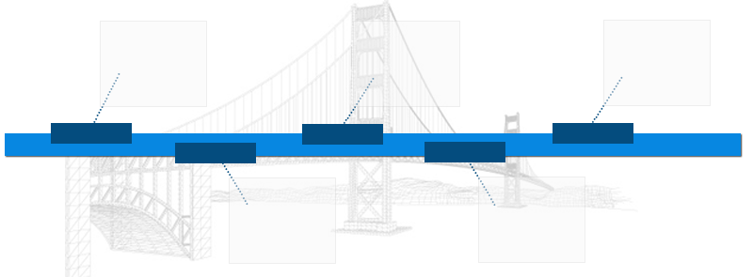
LeXolution IT Services Pvt. Ltd. as Software Developer

Bidonhomes dotcom Pvt. Ltd — Engineering Manager
Nethues Technologies Pvt. Ltd. as Software Developer

Dec'12- Jul'13
Aug'13- Jan’14
Feb’14-Jan’17
Clavax Technologies Pvt. Ltd — Sr. Associate Programmer L2

Feb'17- Till Now

- Work Experience
Feb'17 - Till Now:Bidonhomes dotcom Pvt. Ltd., Gurugram as Engineering Manager

Key Result Areas:
- Designing and developing applications for clients, coding different modules using TDD and BDD approach; interacting with the BAs for requirement gathering; administering & adhering to SLAs and change requests
- Driving efforts towards maintenance of software development practices; adhering to company standards for coding and unit/ functional test coverage; monitoring & motivating the team to produce excellent results
- Managing software updates, patches, and conducting testing and bug ﬁxing with the application development
- Maintaining project, drafts, ﬁles, codes and scripts in an organised manner that allows other team members to make edits/suggestions/ changes
- Mapping requirements and providing customized software solutions to the clients involving finalization of product specifications and selection of appropriate techniques; conducting system study and coordinating with team members for System Design & Integration, Application Maintenance and so on
- Customizing:
- Development plan, code, and programming design to ensure client satisfaction & delivery of project on time within the SLA
- Screens for authorization of deals for clients using technologies such as React JS (Web) with Redux, jQuery,Javascript
- Coordinating with client & Testing Team to identify and implement improvement in application performance
- Conceptualizing methods for application development and ensuring user needs were met; performing data analysis; creating business-critical visual/data report for decision-making
- Participating in the team’s agile software development process; developing solutions and functional/integration tests; supporting production deployments of developed solutions
- Managing large and complex projects or multiple components of a large project involving more than one company’s product; ensuring the maintenance of positive and on-going relationships with stakeholders

Highlights:
- Developed & coded application architecture for different solutions by ensuring the security, performance, availability, compliance, scalability and maintainability aspects
- Identified, conceptualized & documented appropriate technical solution approaches for various business scenarios
- Supported bug fixing, maintained store procedures and executed system enhancements according to user requirements for the application

- Previous Work Experience
Feb'14 - Jan'17: Clavax Technologies Pvt. Ltd., Gurugram as Sr. Associate Programmer L2

Aug'13 - Jan'14: Nethues Technologies Pvt. Ltd. , New Delhi as Software Developer

Jan'12 - Jul'13: LeXolution IT Services Pvt. Ltd., New Delhi as Software Developer

Oct'11 - Dec'12: Asiawebnet , New Delhi as Software Developer

Project Annexure

Bidonhomes dotcom Pvt. Ltd
Bidonhomes — https://deploy.bidonhomes.com
Duration: 2 Years (current project)
Description : Real Estate Property Selling Portal
Technologies : React JS (web) with Redux, Node JS, MySql, Elastic search
Roles:
- Creating APIs in NODE JS as per the business logics
- Implementing frontend development in React JS to provide a better user experience
- Deploying everyday changes to UAT and production servers

Clavax Technologies Pvt. Ltd
Auction Watcher — https://monitor.auction.com/watcher/
Duration:1 Year 10 Months
Description : Panel to Watch Performance & Usage Stats of Auction.com Servers
Technologies : JQuery, JavaScript, Highchart JS, MySql, Memcache

Story Keeper — http://storykeeper.com/
Duration: 4 Months
Description: A website to share your life stories/memories with others
Technologies: JQuery, JavaScript, MySql, DJango REST Framework

OvEssence — https://ovessence.com/
Duration: 10 Months
Description : Online appointment booking system for practitioners and customers
Technologies : JQuery, JavaScript, MySql, DJango REST Framework

LeXolution IT Services Pvt. Ltd
K12 Data — https://k12-data.com/
Duration: 6 Months
Description : Website to get school faculties information on lease
Technologies : JQuery, JavaScript, MySql, SQL Server

